//DS 1307 real time clock

#include <Wire.h>

#include <LiquidCrystal_I2C.h>

#include "RTClib.h"

LiquidCrystal_I2C lcd(0x27,128,32); // Display I2C 128 x 32

RTC_DS1307 rtc;

char daysOfTheWeek[7][12] = {"Sun", "Mon", "Tue", "Wed", "Thu", "Fri", "Sat"};

void setup ()

{

lcd.begin();

lcd.backlight();

lcd.clear();

Serial.begin(9600);

if (! rtc.begin())

{

lcd.print("Couldn't find RTC");

while (1);

}

if (! rtc.isrunning())

{

lcd.print("RTC is NOT running!");

}

rtc.adjust(DateTime(F(__DATE__), F(__TIME__)));//auto update from computer time

//rtc.adjust(DateTime(2014, 1, 21, 3, 0, 0));// to set the time manualy

}

void loop ()

{

DateTime now = rtc.now();

lcd.setCursor(0, 1);

lcd.print(now.hour());

lcd.print(':');

lcd.print(now.minute());

lcd.print(':');

lcd.print(now.second());

lcd.print(" ");

lcd.setCursor(0, 0);

lcd.print(daysOfTheWeek[now.dayOfTheWeek()]);

lcd.print(" ,");

lcd.print(now.day());

lcd.print('/');

lcd.print(now.month());

lcd.print('/');

lcd.print(now.year());

}

LIbrary download:

<https://github.com/fdebrabander/Arduino-LiquidCrystal-I2C-library>

<https://github.com/rodan/ds3231>

For RTC connect: SDA : A4

SCA：A5

VCC： 5V

GND： negetive(GND)

For Lcd display, the way of connecting circuits is the same as RTC see the diagram follow.

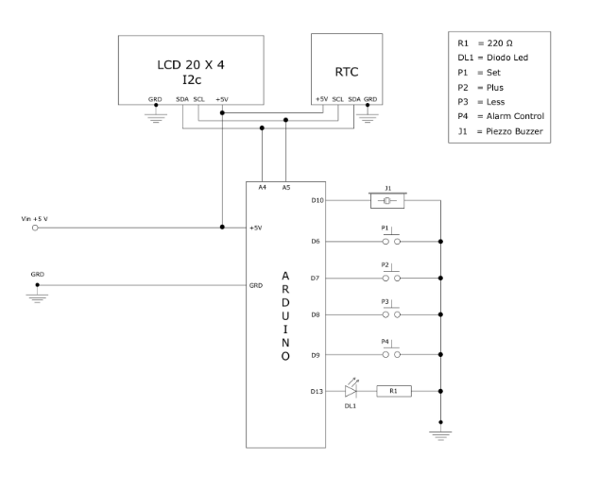

//DS 3231 real time clock

#include <Wire.h>

#include <ds3231.h>

#include <LiquidCrystal.h>

LiquidCrystal lcd(7,8,9,10,11,12); // (rs, e, d4, d5, d6, d7)

struct ts t;

void setup() {

Serial.begin(9600);

Wire.begin();

DS3231_init(DS3231_INTCN);

t.hour=15; // set time from here

t.min=04;

t.sec=0;

t.mday=15;

t.mon=7;

t.year=2020;

DS3231_set(t);

}

void loop() {

DS3231_get(&t);

lcd.setCursor(0, 1);

lcd.setCursor(0, 1);

lcd.print(t.hour);

lcd.print(':');

lcd.print(t.minute);

lcd.print(':');

lcd.print(t.second);

lcd.print(" ");

lcd.setCursor(0, 0);

lcd.print(t.mday);

lcd.print('/');

lcd.print(t.month);

lcd.print('/');

lcd.print(t.year);

}

LIbrary download:

<https://github.com/fdebrabander/Arduino-LiquidCrystal-I2C-library>

<https://github.com/rodan/ds3231>

For RTC connect: SDA : A4

SCA：A5

VCC： 5V

GND： negetive(GND)y.

Note: for DS3231 need to set time first from the code from the t.hour

For Lcd dis play, the way of connecting circuit is same as RTC see the diagram follow.